**Problem Set #1, The length, time & energy coordinate system.**

Submit your answer before Thursday, October 31, 2024, 14:15 hour per e-mail to karsten.rippe@bioquant.uni-heidelberg.de and include [BPC2024] in the subject line

**1.** The table below from van Holde’s book gives the magnitude (or range of magnitudes) of energies for ion-ion, ion-dipole, dipole-dipole, ion-induced dipole, and dispersion (van der Waals) interactions for atoms that experience these interactions within a molecular environment at a distance of r = 0.3 nm.

a) Calculate the corresponding values for distances of 0.2 nm and 0.4 nm.

b) Which interactions are most sensitive to changes in *r* and which are the least sensitive?

c) How would these energies change in an aqueous solution?

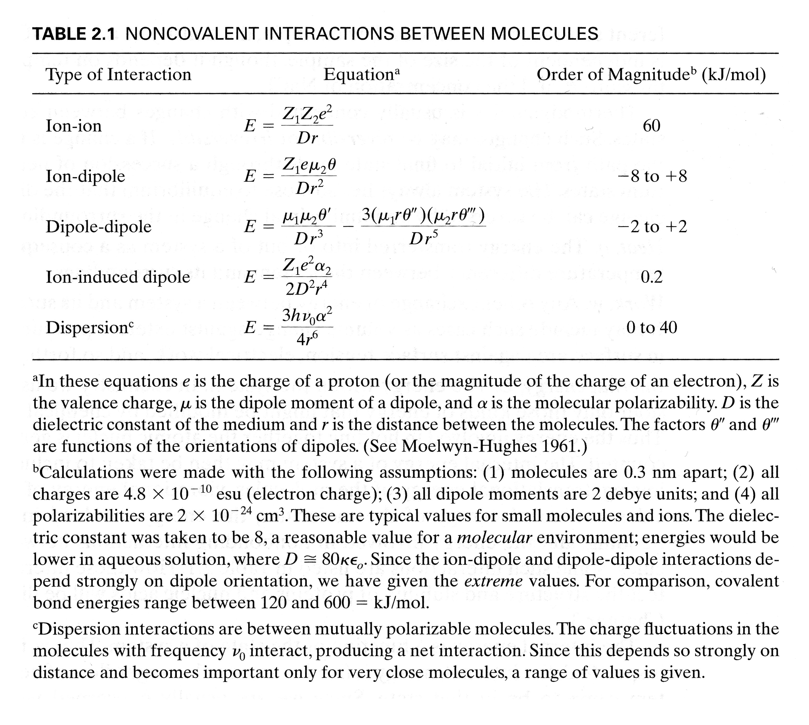

**2.** In the cell some reactions occur spontaneously and continuously if the energy exchanged is low in relation to the thermal energy available.

a) How can you derive the *average value* of the thermal energy available to a protein in the cell in units of *k*B·T?

b) Estimate the value of ∆*G* in kJ mol-1 at 20 ºC for essentially irreversible binding of a ligand to a macromolecule under standard conditions and explain your rationale for choosing this value.

c) RNA polymerase is a molecular motor that generates a force of 25-30 pN during transcription. Estimate the energy in units of *k*B·T if RNA polymerase moves with a force of 25 pN along 1000 base pairs of the DNA template during transcription.

**3.** The following numbers of genes and transcription factors (TFs) have been found: human 20,000 protein-coding genes, 1,600 TFs; Drosophila: 13,000 protein-coding genes, 700 TFs; yeast: 6,100 protein-coding genes, 200 TFs.

a) Outline an approach for estimating the number of transcription factor genes required for regulating a given number of genes, discussing key assumptions, possible biological mechanisms, and any parameters that need to be considered.

b) Use your approach to estimate the number of TFs for C. elegans (21,000), Zebrafish (26,200), and Arabidopsis (27,000). Compare your estimate to the known number of TFs in these organisms and analyze potential sources of discrepancy between the two values.

c) Discuss how the number of genes and TFs could be related to the complexity of an organism and what additional molecular features might increase its complexity.