Problem Set #3, Ligand binding.
Please submit your answer before Thursday, November 28, 2024, 14:15 hour per e-mail to karsten.rippe@bioquant.uni-heidelberg.de and include [BPC2024] in the subject line.

1. Antigen was added to a 1 µM concentration of antibody. The results listed in the table below were obtained.
a) Plot the data.
b) How many antigen-binding sites exist per antibody molecule?
c) Estimate the dissociation constant and explain the limitations of your estimate.

Antigen added (µM) | Measured concentration of free antigen (µM)
0.5 | 0.005
1.0 | 0.0011
1.5 | 0.016
2.0 | 0.021
2.5 | 0.5
3.0 | 1.0
3.5 | 1.5
4.0 | 2.0

2. For the equilibrium binding affinity of lac repressor (present as a tetrameric protein complex) to its specific O₁ DNA binding site in the lac operator a value of ∆G = -48.3 ± 6.6 kJ mol⁻¹ has been measured in vitro.
a) What is the concentration of the O₁ binding site in an E. coli cell?
b) Estimate how many lac repressor molecules would be needed to saturate the O₁ binding site in an E. coli cell. State the assumptions that you make to derive your estimate.
c) How many lac repressor molecules would you need to get the same occupancy for an O₁ binding site engineered into one human chromosome in the nucleus of a human fibroblast cell?

3. The figure below describes the binding of oxygen to hemoglobin. The experimental data are fitted to the Hill equation or to the Monod-Wyman-Changeaux (MWC) model. The parameters that gave the best fit of the model to the data are listed adjacent to the plot.
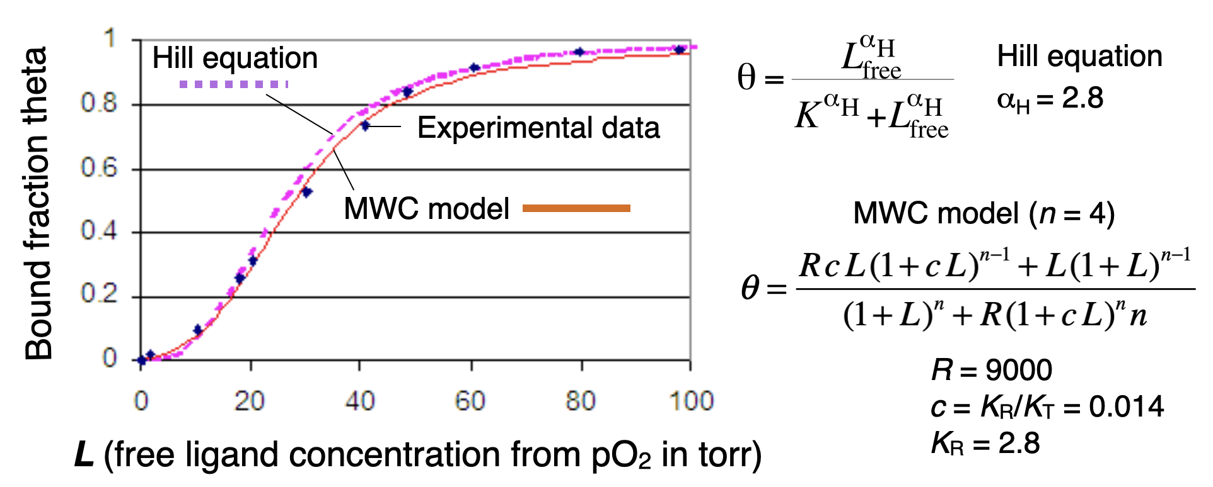

a) Explain the meaning of the parameters α_{H} (Hill equation) and R, c and K_{R} (MWC model). How do the two models compare concerning the number of fit parameters and how well they describe the experimental data?
b) How is the cooperativity of O₂ binding described by the two models and which model is more informative about the molecular mechanism of cooperativity?
c) What is the fraction of proteins in the R state at half saturation of bindings sites for the MWC model for the parameters given in the figure?

