Problem set #4 – chromatin and epigenetics
Please submit your answer before Thursday, January 9, 2025, 14:15 hour per e-mail to karsten.rippe@bioquant.uni-heidelberg.de and include [BPC2024] in the subject line.

1. A solution of H3K9me3 modified mononucleosomes or dinucleosomes with a DNA linker of 15 or 47 base pairs was titrated with dimeric heterochromatin protein 1 (HP1) and HP1 binding was measured. The result is shown in the plot below. The nucleosome substrates are present at a concentration of 1 nM. From other experiments, it is known that dinucleosomes can transition between an open and a stacked conformation, as depicted in the plot.
a) Estimate the dissociation constants for HP1 binding to the 3 different nucleosome substrates.
b) Which binding modes of HP1 could explain the different binding affinities?
c) What theoretical description/model would you use to fit the experimental data?

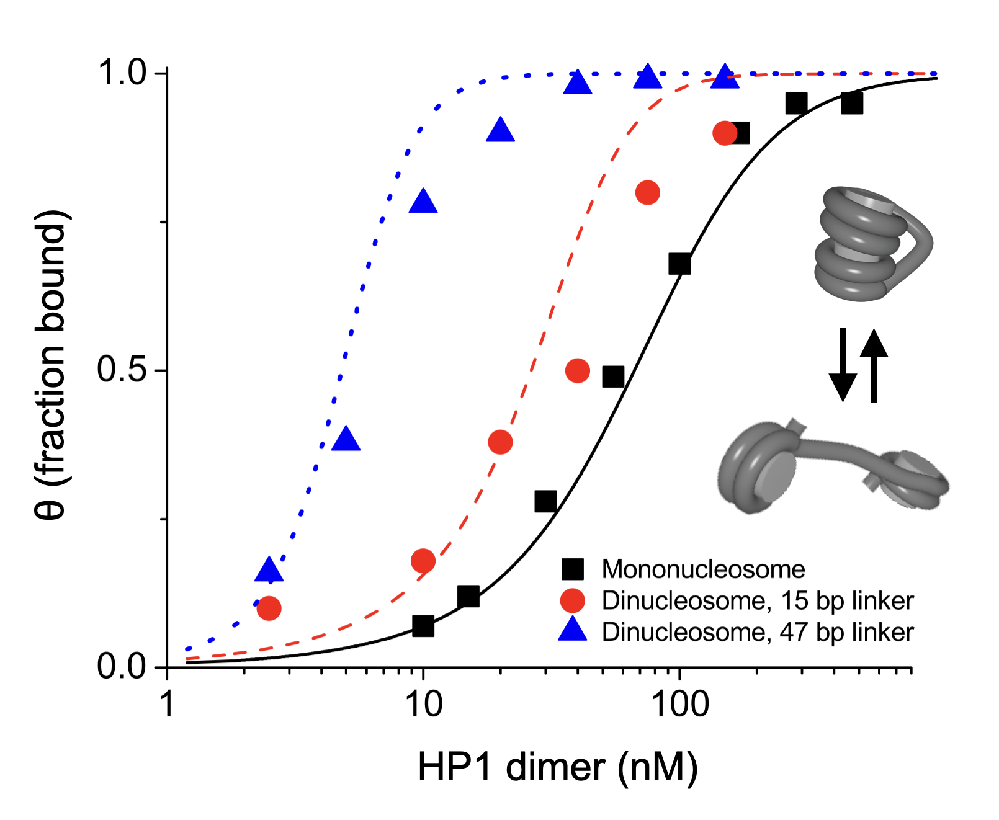

2. The epigenetic landscape in cells is highly dynamic, with different modifications having distinct time scales of persistence.
a) Compare and contrast the typical lifetimes of the following three epigenetic modifications: DNA methylation, histone methylation and histone acetylation.
b) What could account for differences in the stability of the three modifications?
c) Discuss molecular mechanisms that allow the cell to maintain stable epigenetic patterns despite the dynamic nature of the above epigenetic modifications.

3. Epigenetic regulation and bistability can be analyzed with simulations of the nucleosome chain as introduced in the lecture on Dec 5. Use the revised version of the Jupyter Notebook “Bistable_chromatin_model_rev.ipynb” available via the lecture web page that will be available after Friday, Dec 6. With this notebook, bistability can be analyzed in dependence on the following parameters: (i) two-state vs. three-state model, (ii) one vs. two recruiting nucleosomes, and (iii) different F values that describe the strength of the feedback loop.
a) Generate plots for at least three different F values for one comparison that you find particularly interesting to learn something about bistability.
b) Discuss what you see and explain why you selected this comparison.
c) Describe a prediction from your simulations and suggest an experiment to test it.

