Problem Set #6 (the last one): Fluorescence microscopy in living cells
Please submit your answer before Thursday, January 30, 2025, 14:15 hour per e-mail to karsten.rippe@bioquant.uni-heidelberg.de and include [BPC2024] in the subject line.

1. The autofluorescent proteins TagCFP, eGFP, eYFP, and mCherry (the “e” stands for the enhanced versions of GFP and YFP) have distinct fluorescence properties. They are frequently used to analyze protein dynamics and interactions in living cells.
a) Which of the four fluorophores would you select for an experiment that involves only a single-color label? Explain which fluorescent properties are relevant to your choice.
b) Which excitation and emission wavelengths would you choose to resolve the four different fluorescent colors on fluorescence microscopy images of cells with four proteins tagged with these autofluorescent domains? What problems could arise in such an experiment?
c) What combination of two autofluorescent proteins would you use to study the interaction of two proteins in living cells? What are your selection criteria?

2. FRAP and FCS experiments were conducted to measure the chromatin interactions of GFP-tagged MeCP2 protein in pericentric heterochromatin (PCH) regions of mouse cells, which bind to methylated cytosines in the DNA. In the FRAP experiments, 50% recovery is reached after 46 sec, and 5 minutes after photobleaching, the recovery curve reaches a plateau at 82 ± 5 %. The fit of FCS experiments in the PCH regions retrieved two species with diffusion coefficients of D = 0.02 ± 0.01 µm² s⁻¹ and 18 ± 2 µm² s⁻¹. The diffusion coefficient of MeCP2 in the cytoplasm was measured by FCS to be 26 ± 3 µm² s⁻¹.

a) Describe the different types of MeCP2 interaction with chromatin that are detected in these experiments.
b) Estimate the upper limit for the diffusion coefficient that can be detected by FRAP.
c) Which interactions are detected only by FRAP, and why are these not “seen” by FCS?

3. In the nucleus of mouse cells, heterochromatin protein 1 (HP1) is enriched in nuclear subcompartments called “chromocenters” at a concentration of ~10 µM dimer. In chromocenters, 38% of histone H3 is trimethylated at lysine 9 (H3K9me3), to which HP1 dimers bind via its “chromodomain. In an in vitro experiment, different amounts of HP1 are added to a 40 nM solution with DNA fragments that carry 12 nucleosomes with the H3K9me3 modification to reach the indicated average HP1 dimer concentrations. Imaging by light microscopy reveals the formation of liquid droplets that contain HP1 and the 12-nucleosome particle.

Fluorescence microscopy of labeled HP1 and H3K9me3 | In vitro microscopy images of liquid droplets
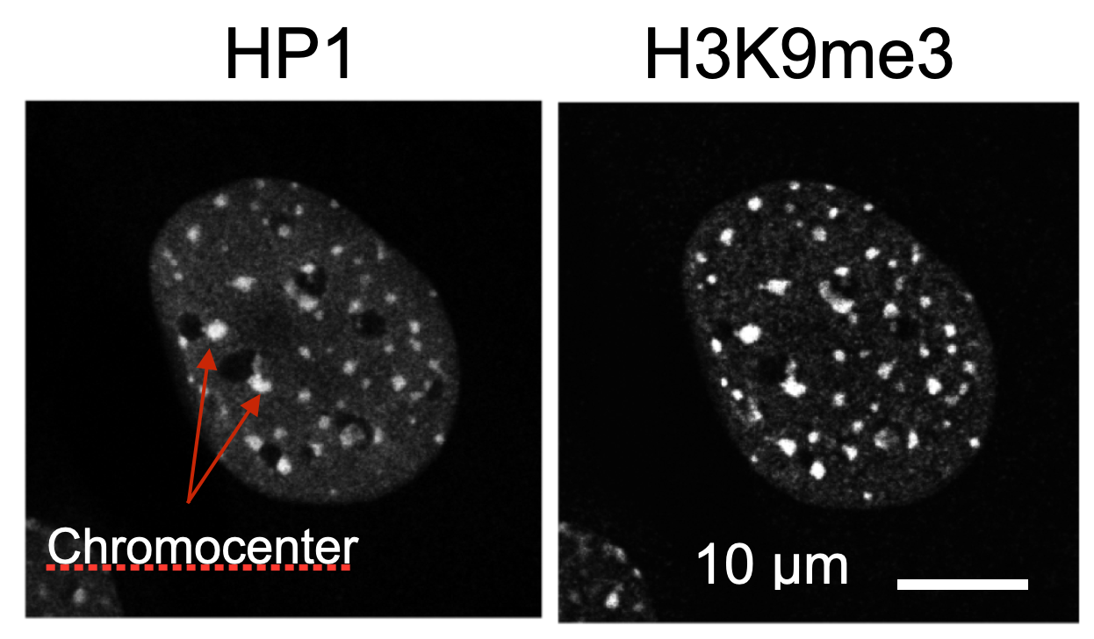 | 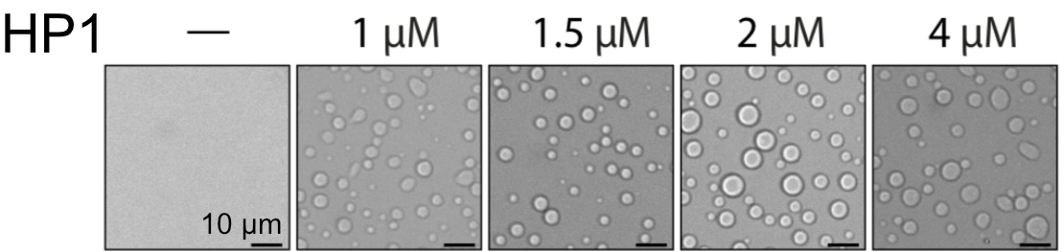

Do you expect chromocenters to assemble via a liquid-liquid phase separation process of HP1 and nucleosomes as they do in the in vitro system? Address the following questions in your answer:
a) What is the estimated concentration of HP1 in liquid droplets in comparison to that in the chromocenters?
b) What is the stoichiometry of HP1 dimers and nucleosomes within a liquid droplet?
c) What is the approximate size of chromocenters compared to the in vitro formed liquid droplets?

