Reference Solution - Problem Set #6: Fluorescence Microscopy in Living Cells

Question 1: Autofluorescent Proteins
The autofluorescent proteins TagCFP, eGFP, eYFP, and mCherry (the “e” stands for the enhanced versions of GFP and YFP) have distinct fluorescence properties. They are frequently used to analyze protein dynamics and interactions in living cells.
a) Which of the four fluorophores would you select for an experiment that involves only a single-color label? Explain which fluorescent properties are relevant to your choice.
b) Which excitation and emission wavelengths would you choose to resolve the four different fluorescent colors on fluorescence microscopy images of cells with four proteins tagged with these autofluorescent domains? What problems could arise in such an experiment?
c) What combination of two autofluorescent proteins would you use to study the interaction of two proteins in living cells? What are your selection criteria?

a) Selection of a fluorophore for a single-color label experiment
For an experiment involving only a single-color label, eYFP would be the optimal choice based on the following fluorescent properties:
Protein | Excitation Max (nm) | Emission Max (nm) | Extinction Coefficient | Quantum Yield | Brightness (% of EGFP) | Structure
TagCFP | 458 | 480 | 37,000 | 0.57 | 63 | Monomer
EGFP | 484 | 507 | 56,000 | 0.60 | 100 | Monomer*
EYFP | 514 | 527 | 83,400 | 0.61 | 151 | Monomer*
mCherry | 587 | 610 | 72,000 | 0.22 | 47 | Monomer
Key reasons for selecting eYFP:
- Superior brightness: eYFP has the highest brightness (151% compared to eGFP), resulting from its high quantum yield (0.61) and high extinction coefficient (83,400 M⁻¹cm⁻¹).
- Signal-to-noise ratio: The brighter signal provides better differentiation between specific fluorescence and background noise.
- Detection sensitivity: Due to its increased brightness, eYFP can be detected at lower concentrations.
- Reduced phototoxicity: Less excitation light is required to visualize eYFP-tagged proteins, reducing the risk of phototoxicity during prolonged imaging.
- Spectral advantages: eYFP has red-shifted excitation and emission maxima (514 nm and 527 nm) compared to eGFP, which helps reduce autofluorescence background and enhances tissue penetration.
While eGFP has slightly better photostability than eYFP, the significant brightness advantage of eYFP outweighs this limitation for most single-color applications.

b) Excitation and emission wavelengths to resolve four different fluorescent proteins
To resolve the four different fluorescent colors in a multi-label experiment, the following excitation and emission wavelengths would be optimal:
Protein | Optimal Excitation (nm) | Optimal Emission (nm)
TagCFP | 440 | 480
eGFP | 488 | 509
eYFP | 518 | 534
mCherry | 587 | 610
These values were selected to minimize spectral overlap while maintaining reasonable signal intensity for each fluorophore.
Potential problems:
- Spectral overlap: There is significant spectral overlap between TagCFP, eGFP, and eYFP, as they all emit in the blue-green-yellow range:
  - TagCFP emission overlaps with eGFP excitation
  - eGFP emission overlaps with eYFP excitation
  - This can cause bleed-through and crosstalk between channels
- FRET effects: Förster Resonance Energy Transfer (FRET) may occur between adjacent fluorophores if tagged proteins are in close proximity (<10 nm):
  - Energy can transfer from TagCFP to eGFP or eYFP without photon emission
  - Energy can transfer from eGFP to eYFP
  - This can lead to decreased donor fluorescence and increased acceptor fluorescence
- Differential photobleaching: The fluorophores have different photostabilities:
  - mCherry is most stable (t₁/₂ ≈ 68 s)
  - eYFP is intermediate (t₁/₂ ≈ 60 s)
  - eGFP is least stable (t₁/₂ ≈ 50 s)
  - Differential bleaching can distort quantitative measurements over time
- Cellular autofluorescence: Cellular components can autofluoresce in the blue and green regions, potentially interfering with TagCFP and eGFP signals.
- Sequential acquisition requirements: Due to spectral overlap, sequential rather than simultaneous acquisition may be necessary, reducing temporal resolution.

c) Combination of two autofluorescent proteins to study protein interactions
For studying protein-protein interactions in living cells, the optimal combination would be eGFP and mCherry. The selection criteria include:
- Spectral separation: eGFP and mCherry have minimal spectral overlap:
  - Excitation maxima differ by ~100 nm (484 nm vs. 587 nm)
  - Emission maxima differ by ~100 nm (507 nm vs. 610 nm)
  - This wide separation minimizes crosstalk and allows for clean detection of each fluorophore
- Brightness and photostability:
  - eGFP has good brightness (100% reference standard) and reasonable photostability
  - mCherry has moderate brightness (47%) but excellent photostability
  - This combination allows for prolonged imaging with good signal detection
- Monomeric nature:
  - mCherry is truly monomeric, minimizing artifacts from fluorophore oligomerization
  - eGFP tends toward weak dimerization but is generally well-behaved in fusions
- Performance in FRET applications:
  - Although not optimal for FRET due to limited spectral overlap, this pair can still be used for co-localization studies
  - For FRET applications, TagCFP and eYFP would be more suitable due to their spectral overlap that make FRET possible, while at the same being separated enough to record the individual TagCFP and eYFP signals needed for the quantitative analysis of the FRET data.
- Established use: Both fluorophores are well-characterized with proven performance in numerous cellular applications.
The large spectral separation between eGFP and mCherry allows for confident detection of co-localization without crosstalk concerns, making this pair ideal for studying protein interactions in complex cellular environments.

Question 2: FRAP and FCS Experiments with MeCP2
FRAP and FCS experiments were conducted to measure the chromatin interactions of GFP-tagged MeCP2 protein in pericentric heterochromatin (PCH) regions of mouse cells, which bind to methylated cytosines in the DNA. In the FRAP experiments, 50% recovery is reached after 46 sec, and 5 minutes after photobleaching, the recovery curve reaches a plateau at 82 ± 5 %. The fit of FCS experiments in the PCH regions retrieved two species with diffusion coefficients of D = 0.02 ± 0.01 µm² s⁻¹ and 18 ± 2 µm² s⁻¹. The diffusion coefficient of MeCP2 in the cytoplasm was measured by FCS to be 26 ± 3 µm² s⁻¹.
a) Describe the different types of MeCP2 interaction with chromatin that are detected in these experiments.
b) Estimate the upper limit for the diffusion coefficient that can be detected by FRAP.
c) Which interactions are detected only by FRAP, and why are these not “seen” by FCS?

a) Different types of MeCP2 interaction with chromatin
The experimental data reveal several distinct modes of MeCP2 interaction with chromatin:
- Stably bound fraction (immobile population):
  - Identified by FRAP as the non-recovering fraction (18 ± 5%)
  - These molecules remain bound to chromatin for periods exceeding the experimental timescale (>5 minutes)
  - Likely represents high-affinity binding to methylated CpG sites in pericentric heterochromatin
  - This fraction is not seen in FCS since it is simply bleached due to its long residence time on chromatin and thus cannot lead to intensity fluctuations from molecules moving in and out the confocal volume evaluated in FCS
  - These interactions may contribute to the chromatin structure in the chromocenters.
- Freely-diffusing species (FCS in the cytoplasm):
  - Identified by FCS in the cytoplasm with D = 26 ± 3 µm² s⁻¹
  - The assumption here is that due to the absence of chromatin in the cytoplasm there are no binding interactions of MeCP2 present that would slow down its mobility
  - The diffusion coefficient of cytoplasmic MeCP2 (26 ± 3 µm² s⁻¹) can thus be considered a reference for the "free" population.
  - The mobility of this fraction can only be measured by FCS since it is too fast to be seen by FRAP, which has a typical time resolution of 50-100 ms as the time it takes to record one image frame (see Question 2b).
- Dynamically bound fraction (slowly mobile population from FRAP and FCS):
  - Identified in FRAP by the slow recovery kinetics (t₁/₂ = 46 sec)
  - Contributes to the 82% of molecules that eventually recover
  - Could be partly include the slowly diffusing species identified in FCS with D = 0.02 ± 0.01 µm² s⁻¹ although FCS will not be able to measure molecules bound to more than a few seconds due to fluorescence bleaching.
  - Likely represents MeCP2 molecules that bind, dissociate, and rebind chromatin during the experiment.
- Transiently binding and fast-diffusing species (FCS):
  - Identified by FCS in the nucleus with D = 18 ± 2 µm² s⁻¹
  - The reduced diffusion coefficient compared to cytoplasmic MeCP2 (26 ± 3 µm² s⁻¹) suggests some level of interaction.
  - The mobility of this fraction can only be measured by FCS since it is too fast to be seen by FRAP, which has a typical time resolution of 50-100 ms as the time it takes to record one image frame (see Question 2b).
  - The fraction of MeCP2 molecules with D = 18 ± 2 µm² s⁻¹ represents very brief and transient interactions of MeCP2 that lead to a slowed-down diffusive mobility that can be described by an effective diffusion coefficient that is lower than the free diffusion coefficient.
These four different interaction modes reflect the complex interactions of MeCP2 with methylated cytosin and nucleosomes as well as other proteins present in the chromocenters like heterochromatin 1 (HP1). Thus, MeCP2 could exert both a structural function for heterochromatin via the stably bound molecules as well as be involved in regulatory processes due transitions between the bound and freely mobile state.

b) Upper limit for the diffusion coefficient detectable by FRAP
The upper limit for the diffusion coefficient detectable by FRAP can be estimated using the following relationship:
$$D_{eff}=\frac{ω^{2}}{4τ_{D}}$$
Where:
- $ω$ is the radius of the bleached spot (typically ~1 µm)
- $τ_{D}$ is the characteristic diffusion time, which is limited by the temporal resolution of the FRAP setup
Assuming a temporal resolution of approximately 100 ms (typical for confocal FRAP setups) and a bleach spot radius of 1 µm:
$$D_{max}=\frac{{\left(1\text{ µm}\right)}^{2}}{4×0.1\text{ s}}=2.5{\text{ µm}}^{2}{\text{s}}^{-1}$$
Therefore, diffusion coefficients greater than approximately 2.5 µm²s⁻¹ cannot be accurately measured by FRAP because the recovery would occur faster than the acquisition time of the first post-bleach image.
This explains why the freely diffusing species in the cytoplasme (D = 26 ± 3 µm² s⁻¹) and the highly mobile species in the nucleus (D = 18 ± 2 µm²s⁻¹) can only detected by FCS and not by FRAP. The latter technique is better suited for studying slower processes such as binding/unbinding events on the scale of several seconds and minutes.

c) Interactions detected only by FRAP and not by FCS
The following interactions are detected by FRAP but not by FCS:
- Stable, long-term binding events:
  - FRAP detects the 18% immobile fraction that doesn't recover within 5 minutes
  - FCS cannot detect completely immobile or very slowly diffusing molecules because:
    - The FCS observation time is typically limited to seconds
    - Immobile molecules don't contribute to fluorescence fluctuations
    - Long-term photobleaching during FCS measurement can eliminate the signal from immobile molecules
- Slowly exchanging populations:
  - FRAP can characterize molecules with residence times of tens of seconds to minutes
  - FCS is most sensitive to events occurring on microsecond to second timescales
  - The slow recovery in FRAP (t₁/₂ = 46 sec) reflects binding dynamics that are too slow for FCS to effectively capture
- Spatially heterogeneous interactions:
  - FRAP samples a larger volume (~1 µm³) compared to FCS (~0.3 µm³)
  - This allows FRAP to detect interactions that might be heterogeneously distributed
  - The small FCS volume may miss rare binding events that FRAP can detect
- Molecules with complex mobility patterns:
  - FRAP can detect the overall mobility of all molecular populations
  - FCS analysis typically assumes distinct species with well-defined diffusion coefficients
  - Complex mobility patterns might be oversimplified in FCS analysis but captured in the shape of FRAP recovery curves
These limitations highlight why combining FRAP and FCS provides a more complete picture of molecular dynamics than either technique alone. FRAP is better suited for characterizing slower dynamics and immobile fractions, while FCS excels at measuring faster diffusion and identifying discrete populations with different mobilities.

Question 3: Heterochromatin Protein 1 and Liquid-Liquid Phase Separation
In the nucleus of mouse cells, heterochromatin protein 1 (HP1) is enriched in nuclear subcompartments called “chromocenters” at a concentration of ~10 µM dimer. In chromocenters, 38% of histone H3 is trimethylated at lysine 9 (H3K9me3), to which HP1 dimers bind via its “chromodomain. In an in vitro experiment, different amounts of HP1 are added to a 40 nM solution with DNA fragments that carry 12 nucleosomes with the H3K9me3 modification to reach the indicated average HP1 dimer concentrations. Imaging by light microscopy reveals the formation of liquid droplets that contain HP1 and the 12-nucleosome particle.

Fluorescence microscopy of labeled HP1 and H3K9me3 | In vitro microscopy images of liquid droplets
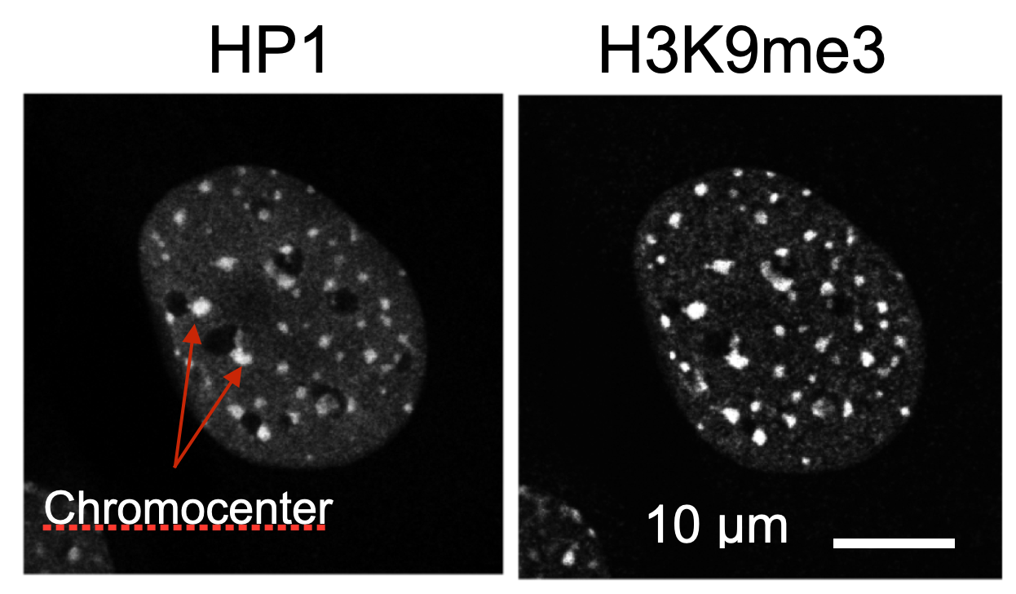 | 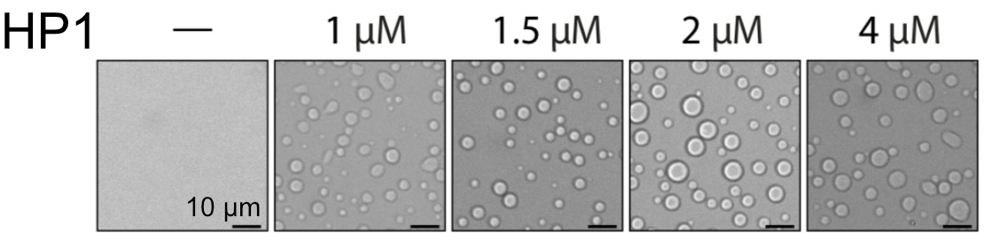

Do you expect chromocenters to assemble via a liquid-liquid phase separation process of HP1 and nucleosomes as they do in the in vitro system? Address the following questions in your answer:
a) What is the estimated concentration of HP1 in liquid droplets in comparison to that in the chromocenters?
b) What is the stoichiometry of HP1 dimers and nucleosomes within a liquid droplet?
c) What is the approximate size of chromocenters compared to the in vitro formed liquid droplets?

a) Estimated concentration of HP1 in liquid droplets compared to chromocenters
The bulk concentration of 1 to 4 µM of HP1 mentioned in the question represents the concentration that would exist if no droplets formed. Once phase-separated droplets appear, the concentration of HP1 within the droplets will be higher than this bulk concentration, while remaining lower than the bulk concentration surrounding the droplets. Increasing the bulk HP1 concentration from 1 to 4 µM will not alter these concentrations, as the saturating or critical concentration of HP1 remains constant above which phase separation occurs, leading to the formation of liquid droplets. Instead, the droplets will simply increase in size if the bulk HP1 concentration is raised. This is evident when comparing images taken at 1 µM and 4 µM bulk HP1 concentrations.
- Chromocenters: The HP1 concentration in chromocenters is approximately 10 µM as stated in the question.
- Liquid droplets: The in vitro experiment shows that liquid droplets form at HP1 concentrations as low as 1 µM in the surrounding solution. However, during phase separation, proteins become highly concentrated within the droplets. The concentration of HP1 in the liquid droplets is likely to be much higher, e.g., 10 to 1000 times, than that in the surrounding solution. Yet, since phase separation redistributes HP1 from the solution where it is freely soluble to enrich it in the droplets, estimating the actual concentration is challenging. It will depend on the stoichiometry of nucleosomes and HP1 (see below) and whether the droplets are predominantly filled with HP1, as anticipated for liquid-liquid phase separation, or if they contain a significant amount of free space within them. That said, the HP1 concentration in the droplets is likely to be significantly greater than 10 µM.
- Theoretical maximum concentration: The maximum possible concentration of HP1 dimers (assuming close packing) can be estimated:
  - Molecular weight of HP1 dimer: ~45.4 kDa
  - Partial specific volume of proteins: ~0.73 mL/g
  - This yields a maximum concentration of approximately 3 mM HP1 dimer if all the volume is filled with HP1 protein
- The dependence of HP1 concentration in droplets on bulk HP1 concentration indicates that, as noted earlier, the concentration of HP1 within the droplets should remain unchanged when the bulk HP1 concentration varies from 1 to 4 µM. Instead, the droplets increase in size with a rise in HP1 concentration, which is also evident in the images.
The concentration of HP1 within the in vitro droplets is likely in the tens to hundreds of µM range, which is higher than the ~10 µM found in chromocenters. This indicates that the in vitro droplets represent a more concentrated state than physiological chromocenters.

b) Stoichiometry of HP1 dimers and nucleosomes within a liquid droplet
The stoichiometry of HP1 dimers to nucleosomes in the in vitro system can be estimated as follows
- Direct binding of HP1 dimers to a nucleosome for the 12 mer array:
  - A nucleosome has two histone H3 molecules each of which carries the H3K9me3 modification in the in vitro experiments with the 12-nucleosome array.
  - HP1 has a chromodomain that binds to the H3K9me3 modified histone H3 tail. Thus, either one HP1 dimer could bind two H3 tails simultaneously (1 HP1 dimer per 1 nucleosome) or a HP1 dimer binds only one histone H3 tail (2 HP1 dimers per 1 nucleosome)
  - For the 12-nucleosome array this would mean that 12 or 24 HP1 dimers are directly bound.
- Additional indirect HP1 binding to the 12 mer array:
  - HP1 dimer could also indirectly bind to nucleosomes that already have HP1 bound to the histone H3 tail with the H3K9me3 modification. This would lead to a higher stoichiometry than 1 or 2 HP1 dimers per nucleosome.
  - This indirect binding could still occur in a stoichiometric manner, i.e. for every HP1 dimer directly bound to a nucleosome another dimer binds indirectly via protein-protein interactions, e. g., via HP1 dimer-dimer interactions via their chromoshadow domain and/or other parts of the nucleosome. This would lead to a stoichiometry of 2 or 4 (or even more) HP1 dimers per nucleosome.
- H3K9me3 binding sites per nucleosome in chromocenters:
  - Each nucleosome contains two histone H3 molecules
  - With 38% of H3 being trimethylated at K9, there are approximately 0.76 H3K9me3 sites per nucleosome
  - This allows for up to 0.76 dimers to bind directly via the specific chromodomain interaction if one dime binds to one H3 tail with H3K9me3.
  - Additional indirect stoichiometric binding of HP1 could increase this binding several fold.
- HP1 to nucleosome stoichiometry in droplets:
  - The bulk concentration of the 12 mer array is 40 nM solution, which corresponds to a 480 nM concentration of nucleosomes.
  - The enrichment and concentration of the 12 mer array and within the concentration of nucleosomes are difficult to predict from the information given in question 3. One scenario would be that the stoichiometry in the absence of phase separation of 1-4 dimers of HP1 that bind per nucleosome does not change as the complex of HP1 and the 12 mer array undergo liquid droplet formation together.
  - However, the droplets become larger if the bulk concentration of the HP1 dimer is raised from 1 µM to 4 µM. This suggests that the stoichiometry of HP1 to the 12 mer is not fixed and could become much larger than the 1-4 HP1 dimers/nucleosome.
  - This leads to a scenario in which the 12 mer array functions as a nucleation site around which HP1 accumulates in a non-stoichiometric manner. This indicates that there is no fixed ratio of a certain number of HP1 molecules per nucleosome; however, as the droplets enlarge around the nucleation sites formed by the 12 mer array, there is an increasing amount of HP1 dimer per nucleosome present in the liquid droplet. This non-stoichiometric assembly surrounding the 12 mer array is a defining characteristic of a phase separation process. The average ratio (~2 HP1 dimers/nucleosome) exceeds what could be accommodated by direct binding to H3K9me3.
These considerations suggest that most HP1 dimers in the liquid droplets are not directly bound to H3K9me3 sites but are likely incorporated through additional multivalent interactions such as:
- HP1 dimer-dimer interactions via the chromoshadow domain
- Non-specific interactions with DNA or nucleosomes
- Protein-protein interactions within the concentrated phase
The extremely high stoichiometries at higher HP1 concentrations suggest that the droplet formation is driven more by HP1 self-association than by specific binding to H3K9me3, especially at concentrations above 1 µM.

c) Size comparison between chromocenters and in vitro liquid droplets
Based on the provided images:
- Chromocenters:
  - Diameter: approximately 1-1.5 µm
  - Typical spherical or near-spherical shape
  - Relatively uniform size distribution
- In vitro liquid droplets:
  - Diameter ranges from ~1.5 µm (at 1 µM HP1) to ~7 µm (at 4 µM HP1)
  - Perfectly spherical shape characteristic of liquid droplets
  - Size increases with HP1 concentration
- Size comparison:
  - At the lowest HP1 concentration (1 µM), the droplets are comparable in size to chromocenters
  - At higher HP1 concentrations (2-4 µM), the droplets are significantly larger than chromocenters
  - The volume ratio between the largest droplets and chromocenters is approximately (7 µm ÷ 1.5 µm)³ ≈ 100×
The significant size difference between chromocenters and the higher-concentration in vitro droplets suggests that the conditions promoting extensive phase separation in vitro are not present in vivo. This indicates that chromocenter formation in cells likely involves additional regulatory mechanisms that limit their size and prevent excessive phase separation.

Do chromocenters assemble via liquid-liquid phase separation?
Based on the analysis of HP1 concentration, stoichiometry, and size comparisons, it appears unlikely that chromocenters assemble via the same liquid-liquid phase separation process observed in the in vitro system. Key considerations:
- Concentration differences: The in vitro droplets likely contain HP1 at concentrations several times higher than in chromocenters.
- Stoichiometry discrepancies: The high HP1:nucleosome ratios in the in vitro system exceed what would be expected from specific binding interactions alone.
- Size differences: The significantly larger size of in vitro droplets at higher HP1 concentrations suggests unrestrained phase separation that is not observed in cellular chromocenters.
- Material properties: Recent studies (Erdel et al., 2020, Molecular Cell) indicate that mouse heterochromatin lacks hallmarks of HP1-driven liquid-liquid phase separation. Chromocenters do not show internal mixing or fusion behaviors typical of liquid droplets.
- In vivo complexity: The cellular environment contains numerous additional factors that regulate chromatin organization, including:
  - Nuclear scaffold proteins
  - Other heterochromatin proteins
  - Chromatin remodeling complexes
  - Additional histone modifications
A more likely model is that chromocenters form through a combination of specific binding interactions between HP1 and H3K9me3, additional protein-protein interactions, and chromatin folding/compaction mechanisms that create dense heterochromatin domains without true liquid-liquid phase separation.
While HP1 can undergo phase separation in vitro under certain conditions, the physiological relevance of this behavior for chromocenter formation in vivo remains questionable. The in vitro system likely represents an extreme case that does not fully recapitulate the regulated assembly of heterochromatin in the nuclear environment.

